HELLO WORLD! In html:

HELLO WORLD in js:

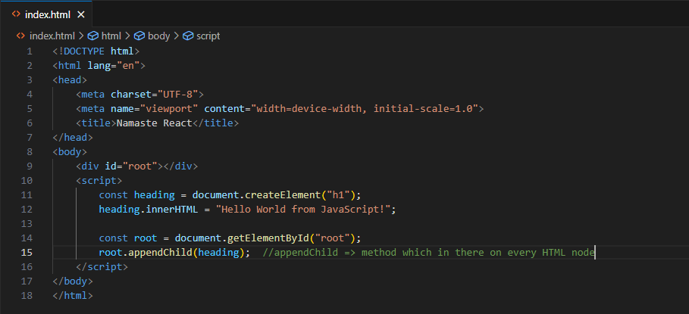

HELLO WORLD in react:

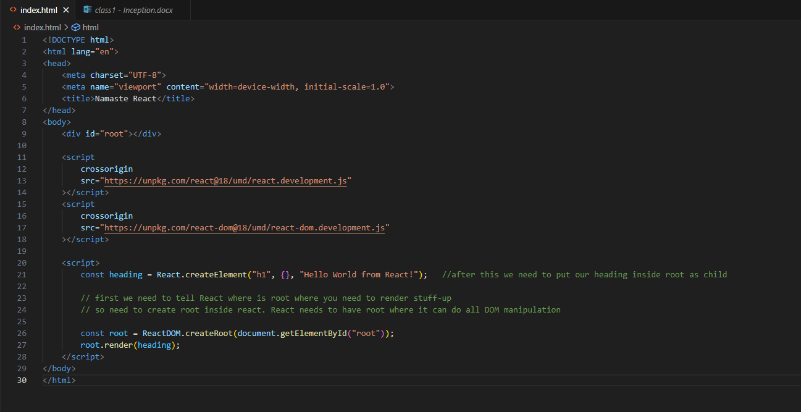

* React.createElement => creating h1 element in react that is a core thing;
* ReactDOM.createRoot() => when we’ve to put react in DOM, we’ll use ReactDOM library
* What is React.createElement?
  + At the end day, it is just an object. And this object is a react element.
  + And this object becomes an HTML that browser understands.
* Root.render(heading):
  + While rendering into DOM, it converts into HTML and put that into DOM.

Note:

* First way to inject React is using CDN (Content Delivery network);
  + CDN => a place where React library is hosted.
    - We just pull-in React, fetch it in our code using CDN links.
* REACT is a library not a framework.
  + Because React can be applied to a small portion of our page itself.
    - React can only work in header also, can only work in footer also, can only work in sidebar also.
    - React can only work in the place whatever you make the root as.
    - It can work independently on a small portion of your page itself.